REpublic OF Moldova:

needs Assessment of Ukrainian refugees with disabilitIES
  - January 2023

TABLE OF CONTENTS
EXECUTIVE SUMMARY 3
INTRODUCTION 5
Research methodology 6
1. DOCUMENTATION AND REGISTRATION 9
2. ACCOMMODATION 13
3. INCOME AND ACCESS TO WORK 20
4. ACCESS TO HEALTHCARE AND EDUCATIONAL SERVICES 24
5. ASSISTANCE 28
6. SAFETY AND INTEGRATION 34
CONCLUSIONS AND RECOMMENDATIONS 35
REFERENCES 37

-----------------------------------------
This research was funded by NRC. Its content is the sole responsibility of the Centre for the Rights of Persons with Disabilities and does not necessarily reflect the view of NRC.

Executive summary
On January 1, 2023, 102,000 Ukrainian refugees were in the territory of the Republic of Moldova, approximatively 10% of them being people with a certain form of physical, sensory or mental disability.
Documentation and registration
- The approval of the Government Decision on granting temporary protection to displaced persons from Ukraine (no 21 of 18.01.2023) will improve the protection and support policies for refugees from Ukraine. The clarity of the normative framework related to refugees from Ukraine has been improved by the fact that the document has concentrated regulations on various fields, which were previously dispersed by various decisions of the Commission for Emergency Situations (CSE), orders of ministries and other authorities.
- Refugees from Ukraine did not face major difficulties crossing the border with the Republic of Moldova. The support provided by the authorities, organizations and volunteers at the arrival points in the country was very helpful for them. Refugees rely largely on the information provided by the government hotline 0 800 800 11, the website https://dopomoga.gov.md, as well as the information shared in profile groups on social networks.
- Currently, a mechanism for identifying and registering refugees, including people with disabilities, is lacking. Such a mechanism, set out under the Government Decision no 21 of 18.01.2023, needs to enable registration of the beneficiaries of temporary protection, namely the elderly persons and the persons with disabilities, in order to improve the services provided to them at the community level.
Accommodation
- Most refugees (66%) are staying with their relatives or in rented housing units. However, Temporary Placement Centres for Refugees (RAC) house the most vulnerable people who cannot afford to pay rent, bills, food on their own.
- Currently, the centres for refugees, although they offer 'basic' conditions of living, persons with disabilities, the elderly persons and children still face physical accessibility difficulties, limited access to the shower, difficulties in using public transport in the region where the RAC is located.
- RAC are no longer a temporary placement solution, as most people are here for a long time, some of them being here since arriving in Moldova. For this reason, the network of placement centres should be reconsidered, so that these centres offer better services (accommodation, food, water and sanitation). Also, RAC buildings should be easier to access by people with disabilities, should be located in such a way as to provide free access to public transport, community services, education, employment, healthcare services, etc.
- The state budget financing procedure for RAC expenses, administered by non-commercial organizations, is too cumbersome, for which reason several non-commercial organizations have given up cooperation with MLSP and rely on support from international organizations and their own donors.
- According to the recommendations of the UN Committee on the Rights of Persons with Disabilities, this reconsideration of placement programs for persons with disabilities must be done in active consultation with organizations of persons with disabilities. The Committee also urges all parties involved to ensure that international funds are not invested in rebuilding, expanding or renovating residential care facilities for people with disabilities, but are instead directed towards the development of independent living solutions and the creation of an accessible community (support services and facilities, home services, customised support, including affordable housing in the community, on equal terms with others).
Income and access to work
- The monthly financial support provided through the UNHCR Cash Assistance program is the main source of income for most refugees with disabilities. Its amount (2200 lei and 700 lei monthly for the cold period of the year) generally covers the minimum necessities of existence for an ordinary person. However, it is important to keep in mind that people with disabilities often have significant expenses related to their disability: assistive devices (walking sticks hearing aids, etc.), medicines and medical supplies, transport services. These expenses are not covered by any national assistance program.
- Ukrainian citizens have the right to work in the Republic of Moldova; however we note that only 1% of them are officially employed. In order to integrate them into work, refugees with disabilities need employment support services: assisted employment to identify the job that meets their skills, intermediation with the employer.
Access to medical and educational services
- Access to medicines and medical services is the most important issue facing Ukrainian refugees with disabilities and elderly refugees. The current mechanism for compensating the costs borne by healthcare providers does not cover all refugee needs.
- Refugees from Ukraine are in no hurry to integrate their children with disabilities into the educational system of our country. But this seems to be a general trend, characteristic of all refugees who prefer their children to study from home, including to attend 'online' classes of schools in Ukraine.
Assistance
- The assistance system for Ukrainian refugees was organized for the 2022 spring-summer period with a high flow of refugees, who were mostly just transiting the country's territory. Now it must be adapted to current realities and conditions for refugees who stay for a longer period need to be organized. It is important that support services for refugees with disabilities cover such needs as: accessible transportation, assistive and mobility equipment, orthopaedic footwear, support services (such as personal assistance services, services for children with ASD) and other types of social assistance and support services in the community.

INTRODUCTION
On January 1, 2023, 102,000 Ukrainian refugees were in the territory of the Republic of Moldova. Since the beginning of the war, more than 1.6 million Ukrainian citizens entered the Republic of Moldova. National authorities received over 11,000 asylum applications in total.
According to the data of the National Agency for Social Assistance, 2,767 people are housed in 65 temporary placement centres for refugees (RAC). 41% of RAC reported that they accommodated people with disabilities.
Official published data lack information on how many Ukrainian refugees with disabilities are in the Republic of Moldova. We estimate that they constitute no less than 10% of the total number of refugees.
According to a study carried out by UNHCR, of all refugees in the Republic of Moldova: 12% reported being accompanied by at least one family member with disability, 10% - by someone with a serious medical condition and 9% - by an elderly person.
Such data broadly correspond to the data of the World Health Organization, which estimates that globally, around 16% of the population experiences a significant form of disability. We need to keep in mind the distinction between the definition of disability of the UN Convention on the Rights of Persons with Disabilities (UN CRPD) and people who officially hold a disability certificate.
According to the UN CRPD and national legislation, the term 'persons with disabilities' includes those who have long-term physical, mental, intellectual or sensory impairments which in interaction with various barriers may hinder their full and effective participation in society on an equal basis with others'. Therefore, the questions proposed by the Washington Group on Disability will be used to identify persons with disabilities.
- Do you have trouble seeing, even if you wear glasses?
- Do you have trouble hearing, even if you use hearing aids?
- Do you have trouble walking or climbing stairs?
- Do you have trouble remembering or concentrating?
- Do you have trouble with personal care, such as washing or dressing?
- Using your usual language, do you have trouble communicating, for example understanding or being understood?
In the Republic of Moldova, people holding an official certificate of disability represent 6.5% of the total population of the country with usual residence, and children with disabilities – 1.9% of the total number of children. In Ukraine, persons with disabilities also constitute 6.58% of the total population.
In the official statement of the UN Committee on the Rights of Persons with Disabilities of April 14, 2022, it expresses its deep concern about the situation of persons with disabilities from Ukraine. The Committee urges all states, UN agencies, civil society and other stakeholders involved in humanitarian action to recognize and respond to the needs of persons with disabilities. Action must be taken to ensure that all persons with disabilities are considered, protected and have immediate access to humanitarian assistance, taking into account their individual support requirements. They must receive support tailored to their individual needs at border crossing points, reception and accommodation centres and to be provided with relocation assistance.

Research methodology
The study is part of the activities of the project 'Improving protective environment for Ukrainian refugees with disabilities in the Republic of Moldova', implemented by the Centre for the Rights of Persons with Disabilities (CDPD) with the support of the Norwegian Refugee Council (NRC).
The purpose of the study is to identify humanitarian priorities by analysing the needs of the affected communities and their coping mechanisms, as well as by understanding the response capacities of the authorities and the gaps that exist between these needs, capacities and the current conditions of Ukrainian refugees with disabilities in the Republic of Moldova.
The main objectives of the study are:
1. Identifying the specific needs of Ukrainian refugees with disabilities regarding access to essential services, particularly related to housing, nutrition, education, health, protection, mobility, community inclusion and participation.
2. Analysing the legal framework and mapping of existing services available to Ukrainian refugees with disabilities: information services, shelter, transport, schools, provision of assistive devices, medical services, etc.
3. Identifying the barriers and factors enabling access to protection services by Ukrainian refugees with disabilities. These may include attitudinal, environmental/physical, communication and institutional barriers.
4. Understanding how protection risks may vary for women and men, for people with different types of disabilities, ethnicity, age, etc.
Key areas of needs assessment:
- Documentation and registration;
- Accommodation;
- Income and access to work
- Access to medical and educational services;
- Assistance;
- Safety and inclusion.
STAKEHOLDERS
The needs were assessed by collecting information from the following stakeholders:
1. People with disabilities displaced from Ukraine.
The needs of people with different types of disabilities have been considered: sensory (visual, hearing impairments), physical (mobility impairments), intellectual and psychosocial disabilities.
2. Relatives, family members and local hosts.
3. Workers of Temporary Placement Centres for Refugees (RAC).
4. Workers of national and international NGOs, organizations of persons with disabilities helping refugees with disabilities.
5. Representatives of central public authorities and local authorities that have programs for refugees: The National Agency for Social Assistance (ANAS), the Ombudsman office and local social assistance departments.

Applied research methods
The research was carried out between October 2022 and January 2023, using the following methods:
1. Qualitative research
- 20 interviews were organized with refugees with disabilities, their family members, support persons, RAC representatives, active CSOs, LPA representatives, ANAS representatives, etc. Following these interviews, the beneficiaries' current situation, living conditions, needs and support services provided were determined.
- 3 regional focus groups were organised: Chisinau (November 22), Cahul (December 16), Ungheni (December 29, 2022), which were attended by representatives of LPAs, RAC, CSOs, refugees with disabilities and members of their families.
2. Analysis of documents and normative acts
- Analysis of the legal framework in the field, in particular: Government decisions, decisions of the Commission for Exceptional Situations (CSE), orders of the Ministry of Labour and Social Protection, the Ministry of Health, etc.
3. Analysis of quantitative data collected based on appeals to the CDPD hotline
The quantitative information in the database of the approximately 210 beneficiaries of the CDPD project 'Improving protective environment for Ukrainian refugees with disabilities in the Republic of Moldova', carried out with the support of the Norwegian Refugee Council (NRC), was analysed. Refugees were identified both following direct visits to the RAC and appeals to CDPD hotline: 08000 8800
Limitations of the study
The primary aim of the study was to examine the situation of Ukrainian refugees with disabilities and map the challenges and support mechanisms for them. Not all general issues related to the refugee protection and support system have been examined in detail except insofar as issues directly concern persons with disabilities. The study did not aim to present quantitative results. Administrative data collected under the refugee support project were used to illustrate trends and visualize the needs of refugees with disabilities in numerical terms.

Documentation and registration
- Assigning IDNP to refugees. The Public Services Agency registers foreign refugees from Ukraine and assigns them a personal identification code (IDNP) upon presentation of one of the following documents: a. for minors – birth certificate, national identity document (identity card), passport; b. for adults – the national identity document (identity card) or passport. All entities under public and private law, including natural persons, who are not connected to state information resources, will access information on the state identification number (IDNP) of Ukrainian citizens on the portal https://dopomoga.gov.md. The IDNP code is needed to interact with government agencies to: use government services when applying for a job, enrolling children in kindergarten or school, opening a bank account, registering their own company, etc.
- Temporary protection. At the Government meeting of 18.01.2022, the Government Decision on granting temporary protection to displaced persons from Ukraine was approved. This stipulates that people who will request temporary protection will obtain an identity document, issued by MIA for a period of one year. The data on the beneficiaries of temporary protection will be registered in the Automated Information System and will be available through the MConnect interoperability platform. This will allow a more efficient management of migration flows, the legalization and monitoring of refugees on the country's territory. The regulation provides for a monitoring of whether people have returned to their country of origin, as well as the express establishment of rights to accommodation services and measures, social, medical and educational assistance, protection against abuse, exploitation and discrimination. The Regulation will enter into force as of March 1, 2023.
- Most of the persons with disabilities we have identified are women and elderly persons. Of all people with disabilities from Ukraine, who turned to the CDPD for support, 68% are women and 32% are men (Figure 1). Most of the refugees are aged over 65 (46%), 32% are aged 35-64, 10% are aged 18-34. 12% of refugees requested support for children with disabilities (Figure 2).
- By type of disability. 55% have general disability, chronic conditions, 20% - mobility disability, 7% - psycho-social or intellectual disability, 10% - visual disability and 5% - hearing disability (Figure 3).
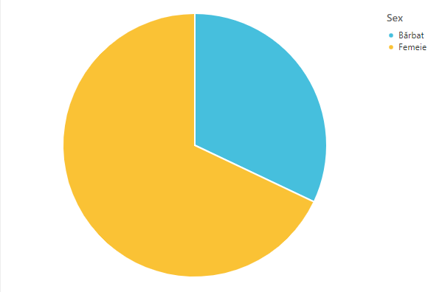
Figure 1. Ukrainian refugees with disabilities who turned to the CDPD for support, gender distribution
32%
68%

Figure 2. Ukrainian refugees with disabilities who turned to the CDPD for support, age distribution

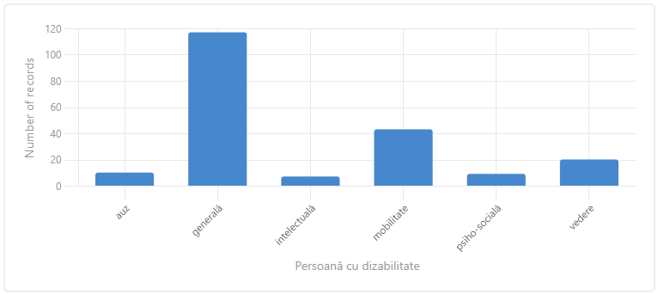
55%
10%
4%
20%
3%
5%
Figure 3. Ukrainian refugees with disabilities who turned to the CDPD for support, disability type distribution (Note: multiple choices are possible)

- Most of the identified persons with disabilities are not from border regions with the Republic of Moldova, which means they cannot return home so easily and could stay for a longer period in our country. Only 35% of persons with disabilities are from Odessa, 26% – Nikolaev, 10% – Kyiv, 5% – Zaporozhe, 4% – Kharkiv, etc. (Figure 4).

Figure 4. Ukrainian refugees with disabilities who turned to the CDPD for support, distribution by regions they came from
- The main problems in connection with documentation consisted in the lack of identity/disability documents or their expiration. 3.4% of support appeals to the CDPD during this period were related to documentation issues. The people who came in the first months of the war did not have time to prepare and take all the identity documents with them. Also, in other cases, during the stay in the Republic of Moldova, the term for the documents expired and people had to go to the Embassy/Consulate of Ukraine or return for a specific time to Ukraine to make those documents. Some refugees had no problems with documentation. They had all the documents on them: passport, disability certificate, etc.
- People with disabilities encounter difficulties in accessing the services of the Embassy of Ukraine in Chisinau and the Consulate in Balti. It is complicated for the person to leave for Chisinau from the remote localities of the republic. Also, the person has to come twice, to submit the documents and then to pick them up. Organizations of persons with disabilities in Moldova have offered support in providing transport for refugees with disabilities to come to the Embassy of Ukraine several times. Another difficulty is that a consular fee of $140 is charged for the preparation of the documents, which is a significant amount.
- Most of the difficulties with documentation were reported to third-country nationals who resided in Ukraine, some of whom even owning property, but holding the citizenship of other post-Soviet states (Russian Federation, Republic of Moldova, Armenia, etc.). These people reported difficulties when crossing the border with the EU and, for this reason, remained on the territory of the Republic of Moldova. A family with a young child with disability, was stopped on their way to Germany and a person who, being married to a Ukrainian, was refused entry to the EU. A person with a hearing disability who has Russian citizenship but has resided in Ukraine for many years was detained for several days in custody in Ukraine, then arrived in Chisinau. According to UNHCR data, 97% of refugees are Ukrainians.
- Crossing borders did not pose difficulties for most refugees with disabilities. During the interviews, they said that they were helped by a large number of volunteers who offered transport, food, accommodation, information, etc., especially during March-April 2022.
In the first months, refugees arrived at the border with evacuation transport from conflict zones, with their own or rented transport. Many refugees did not know exactly where they would end up in Moldova, had no prior arrangements and were guided by volunteers at the border. Some refugees spent their own money on transport services to the border with the Republic of Moldova, amounting to 450 USD. Since June 2022, refugees arrived in Moldova, in particular, by public transport.
Refugees relied on the government hotline for information. The informational support line 0 800 800 11, along with https.dopomoga.gov.md, is a basic source of information and it is important that this line provides the appropriate support for people with disabilities.
- The mechanism for identifying and registering persons with disabilities is lacking. Territorial Social Assistance Structures do not always know the full information about Ukrainian refugees who are in their territory. We do not have an exact geographical representation of where the refugees are in Moldova. Local authorities generally have data on the number of refugees in their territory, including people with disabilities, however these data have not yet been aggregated. Improving the mechanism for identifying the persons with disabilities with the registration for the temporary protection status and the assignment of the IDNP code would be welcome.

ACCOMMODATION
- Most refugees are staying with their relatives or in rented housing units. According to UNHCR data, 43% of refugees are staying with (acquaintances) relatives, and 22% rent a home. Only 4% are in refugee placement centres (RAC).
- On December 27, 2022, 67 RAC with a total capacity of about 4100 seats were active.. (Figure 5). Since February 2022, 130 provisional centres and temporary refugee placement centres (RAC) have been opened, with a total accommodation capacity of more than 10,000 people. In total, by August 2022, more than 65,000 people have been accommodated in these centres. Refugees from Ukraine are accommodated free of charge in the Centres, and they have access to the facilities they can offer, including Internet. According to Government data, the average cost of accommodation for a person is 130 lei per day.
- It is believed that the refugees are mostly concentrated around the big cities, such as Chisinau, Balti, Cahul, etc. 33% of functional RAC and 51% of the total number of placed people are concentrated in Chisinau.
- Additionally, a network of temporary centres was created in the border area. Between 24.02 and 19.06.2022, 8,788 foreigners were registered in the temporary centres managed by the Ministry of Internal Affairs.
- RAC activity takes place on the basis of MLSP Order no. 21 of 26.02.2022 regarding the approval of the Regulation on the organization and operation of the Temporary Placement Centre for refugees and the staff and expenditure rules. The setup of a RAC is done by ANAS order following a request by the requesting organizations. Subjects that have the right to set up temporary placement centres for refugees are:
- Territorial Social Assistance Structures (STAS)
- State-owned enterprises
- Majority state-owned companies
- Non-commercial organizations
- Public institutions under the Central Public Authorities (CPAs)
- Level 1 Local Public Authorities

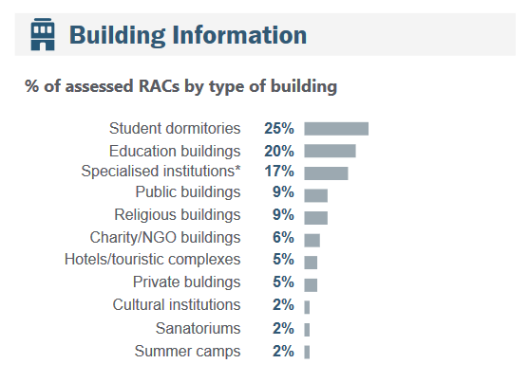
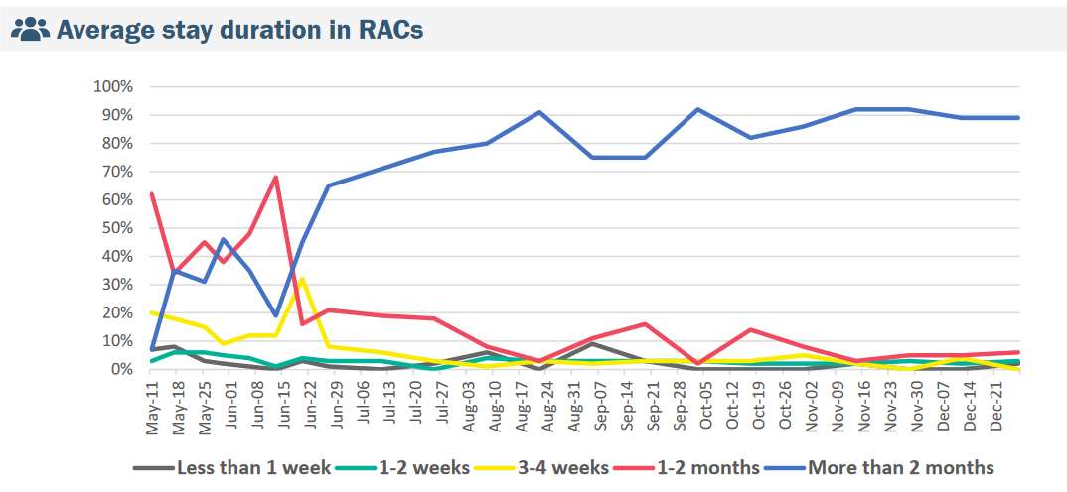
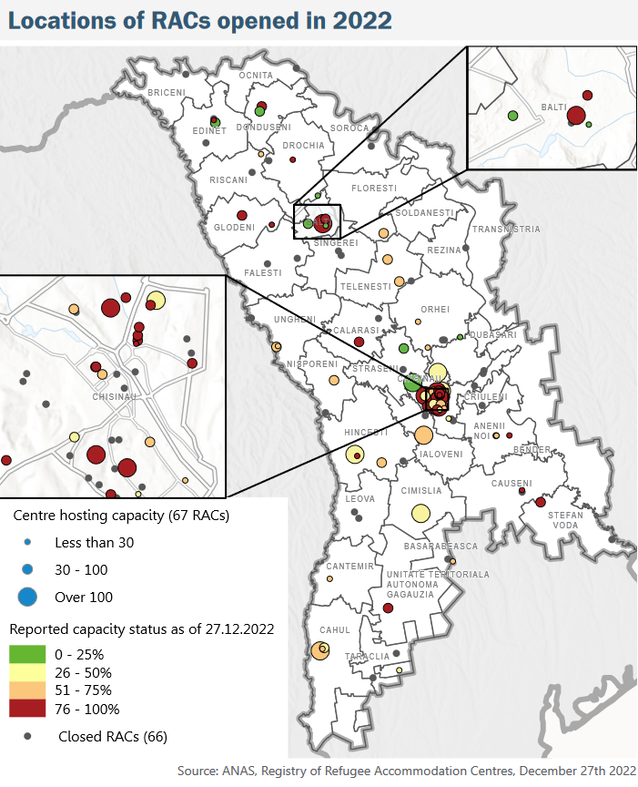

Figure 5. Information about RAC. Source: ANAS

- According to the data provided by ANAS, in December 2022, 112 people with disabilities were placed in the RAC network, which is 4.1% of the total number of people placed. 11% of residents are over 65 years old.
- Since the beginning of the war, the RAC network coordination and placement mechanism has not paid sufficient attention to the needs of persons with disabilities. People with hearing disabilities were placed as indicated by the Moldovan Association of the Deaf. People with locomotor disabilities are mainly placed in the Placement Centre for elderly people and people with disabilities from Chisinau, in RAC Greblesti (Straseni) or in other centres, at a great distance from the infrastructure. Although the accessibility of the buildings of these centres has improved during 2022, due to the location of the RAC, people with disabilities have reduced access to transport and respectively to medical services, education, support services and community integration options.
Note that Moldova is a country with significant inequalities between urban and rural areas. Therefore, where refugees are accommodated will have a significant impact on the types and level of assistance they will receive from the government as well as other humanitarian actors.
People with disabilities placed in RAC, in many cases, did not choose the centre, they called the hotline and were sent to a specific centre. Two RACs were provided per week, and refugees who called were directed to these centres. In some cases, people changed the placement centre because they were not satisfied with the conditions in the RAC they were initially placed in.
- Ukrainian people with disabilities face a low level of accessibility of both RAC buildings and private homes. Due to inaccessibility, refugees have had to change several locations to find a more accessible location, or are forced to stay in certain centres because they offer a minimum of accessibility, although they are unsatisfactory in other respects. 46% of RAC were in educational institutions or student dormitories, 17% – in specialized institutions.
The Help Age study also confirms that RAC are usually opened in reusable buildings that used to be educational institutions, specialized institutions (e.g. for persons with disabilities), hotels or student dormitories. There is therefore substantial variability in their suitability for longer stays; for example they may not have an accessible kitchen or enough toilets. Also, some elderly people have complained that it is difficult for them to climb the stairs (as their rooms are on the upper floors) or that they have problems using the bathroom facilities (they have a bathtub, but they have joint problems, so they cannot use it).

Mrs A. (Nikolaev): 'I was proposed to move to another centre with better conditions, it is warmer, but I refused, because there are stairs on the 1st floor. I cannot climb the stairs'.

- People with serious medical conditions, people with mental disabilities, and children with disabilities have special requirements regarding accommodation conditions, which must be taken into account in the RAC. They cannot be in the rooms with other people except close family members. They cannot stay in overcrowded rooms. According to ANAS data, in RAC, 66% of the available places are occupied. During the monitoring visits in RAC, the administration mentioned that almost all the rooms are occupied, and places are available only if people agree to live with other people/families, in the same room.
- RAC provide basic conditions of convenience. However, young children, the elderly persons, people with mobility and vision disabilities have special needs related to access to water and sanitation services, which should be taken into account.
The refugees placed in RAC say that they have minimal conditions: it is warm, they do not pay for accommodation, they are fed twice a day, they have hot water, WC, shower. In some RAC, support bars have been installed for people with mobility disabilities, which facilitate access to the WC and shower. However, in some RAC visited, located in student dormitories, there is only one shower on the ground floor, used by all against a schedule. Residents have complained that it is difficult to access hot water/shower, this is why most of them bathe in their rooms. On the 2nd floor there are tap heaters, but they cannot keep up with the number of people. Small children cannot be taken to the common bathroom on the ground floor (used by about 50 people placed in the centre) for hygienic reasons. Also, the interviewed people believe that the winter period will be difficult for children, because when climbing the stairs after the bath, they can catch a cold.
- People prefer to stay in the community, but are unable to pay for rent and utilities. People living in rented accommodation face significant difficulties during winter for paying for energy services. Of the total number of people who called for CDPD support, 4% requested assistance in identifying a place to live or improving living conditions. Some people have asked to be helped to be placed in the RAC because they will not be able to pay for the services for the cold period of the year.
According to the Help Age report, 27% of the elderly persons surveyed, who live in the community, reported paying rent for their accommodation. Note that this cannot be applied only to those who live in rented apartments. Some of those (14%) who live with relatives or friends also pay rent. In addition, 20% of community-accommodated elderly reported that they cannot afford to pay for their rent. In some cases, this can lead to not paying for the services: And in other cases, the elderly persons would prefer to contribute to the housing costs of friends or family members who host them, but lack the financial resources to do so.
- RAC are no longer a temporary placement solution, as most people are here for a long time, some of them being here since arriving in Moldova. RAC constitute a long-term placement option for refugees. The average length of stay for 89% of people in RAC exceeds 3 months. Many of them have been here since arriving in Moldova.
For this reason, the network of placement centres for vulnerable groups should be reconsidered, in order that these centres offer better services (accommodation, food, water and sanitation); the buildings have to be more accessible to people with disabilities and their location has to allow access to public transport, community services, education, employment, medical services, etc. Alternatively, the possibility of community rental housing support for vulnerable groups should be analysed.
- The state budget financing procedure for RAC expenses, administered by non-commercial organizations, is too cumbersome, for which reason several non-commercial organizations have given up cooperation with MLSP and rely on support from international organizations and their own donors.
RAC benefit from the support of international organizations and MLSP/ANAS. During the interviews, we were told that the procedure for financing the activity of the refugee centres is cumbersome, many NGOs have given up requesting compensation for expenses, despite the fact that they continue to accommodate refugees, trying to manage on their own. Most of the maintenance expenses of these centres are currently covered by international projects and organizations, also the salary expenses of the centres’ staff. It takes about 2 months until MLSP reimburses the expenses incurred by RAC. In December 2022, the Commission for Extraordinary Situations approved financial allocations for RAC for the period October-September 2022. Only 5 CSOs appear in this list, although according to the information published in the weekly bulletins, 14 RAC are managed by NGOs, religious institutions and other private organizations.
- Certain costs related to the maintenance of RAC have been progressively taken over by international organizations/NGOs, such as food programs, payment for communal services, provision of hygiene products, renovations, etc.
The placement centres are provided with free food through the World Food Program and CRS, Caritas, Solidarite International, AAR Japan, which ensured the distribution of more than 1,517,580 hot meals for refugees from Ukraine. All food services are mainly based on catering, by contracting local catering service providers.
- For Temporary Placement Centres for refugees, created by state-owned enterprises, majority state-owned companies and non-commercial organizations, with the approval of ANAS, MLSP covers the following costs, based on detailed reporting and approval by the Ministry of Labour and Social Protection:
    - personal hygiene items, protective masks, disinfectant; diapers, infant formula; conditions for the preparation and/or serving of food, foodstuffs or catering services;
    - staff expenses within the limit of 4250 lei per full-time employee per month;
    - expenses related to taxes directly caused by the activity of RAC;
In order to cover the operating costs of RAC, created by public institutions subordinate to central public authorities, state-owned enterprises, majority state-owned companies and non-commercial organizations, within the limits of the Expenditure Norms, MLSP acquires services by using the negotiation procedure without prior publication of a participation announcement, according to the provisions of Article 56 para. (1) letter b) of Law no. 131/2015 on public procurement.
- Starting with March 30, in order to avoid the risks related to the trafficking of human beings, the organized accommodation of refugees in centres is not allowed without the notification of ANAS. Unapproved centres, which will operate without the notification of the National Agency for Social Assistance, will be automatically closed.
- The cessation or suspension of the activity of Temporary Placement Centres for refugees, the creation of which was approved by ANAS, is ordered by an administrative act of the heads of the entities or structures entitled to create them, with the notification of ANAS.
- A major challenge for RAC is paying the bills for the cold period of the year. For this purpose, the CSE Decision prohibits, during the cold period of the year, the disconnection of Temporary Placement Centres for refugees from utilities. Bills for utilities and other expenses generated directly by the RAC activity, carried out during the cold period of the year and authorized by ANAS, can be paid by UNHCR through ACTED within the assistance limit of USD 13.00.000 for November and December 2022, as well as by IOM within the assistance limit of USD 450,000 for January-March.
- Problems with statistical data on the location of persons with disabilities, including those placed in RAC. ANAS and UNCHR in their periodic reports do not publish the number of persons with disabilities placed.
Moldova Refugee Accommodation Centre (RAC) Weekly Needs Monitoring, published by ANAS, UNHCR, REACH, does not contain the information about the number/percentage of people with disabilities placed in these centres. The only information published in March 2022, is the percentage of centres that reported having people with disabilities. This percentage increased progressively from 20% in March 2022, to 30% in July and reached 42% in December 2022.
It is recommended that the RAC Weekly Needs Monitoring report contain data on people with disabilities disaggregated by districts, gender and type of disability.
- According to the recommendations of the UN Committee for persons with disabilities, ”all parties involved to ensure that international funds are not invested in rebuilding, expanding or renovating residential care facilities for people with disabilities, but are instead directed towards the development of independent living solutions aiming at renovating and setting up an accessible community (support services and facilities, home services, customised support, including affordable housing in the community, on equal terms with others)”.

Income and access to work
- Income and access to work are at the top of the problems faced by Ukrainian refugees in Moldova. According to UNHCHR data, monetary aid (56%), material aid (25%) and employment (21%) are among the most important needs of refugees (Figure 6).

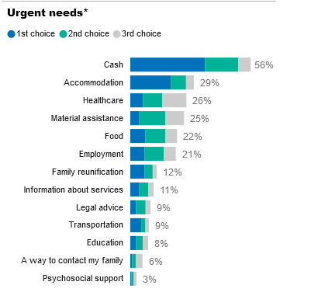
Figure 6. Most important need of Ukrainian refugees in Moldova. Source: UNCHR
- By the provision of CSE, during the state of emergency, by derogation from Chapter IV of Law no. 200/2010 regarding the regime of foreigners in the Republic of Moldova, Ukrainian citizens have the right to work on the territory of the Republic of Moldova without obtaining the right of temporary residence for work purposes. Ukrainian citizens are employed based on the individual fixed-term employment contract, for the period of the state of emergency, with the mandatory notification, within up to 5 days from the date of conclusion of the contract, of the National Employment Agency (ANOFM) by the employer, with submission of the following documents in electronic format or on paper: a. copy of the identity document of the Ukrainian citizen; b. copy of the employment contract, drawn up according to the applicable legislation for citizens of the Republic of Moldova; c. information regarding the personal number code (IDNP) assigned to the Ukrainian citizen.
- About 1% of the total number of Ukrainian citizens in the Republic of Moldova is officially employed. According to ANOFM data, by 19.01.2023, notifications were received from economic agents about the employment of 959 citizens of Ukraine, of which 696 were women and 253 were men. Most Ukrainian citizens are employed in: Chisinau (720), ATU Gagauzia (40), Balti (33), Ungheni (23), and Cahul (18). According to employers' notifications, citizens of Ukraine have been employed in the following professions: programmer, engineer, sewers, salesman, salesman-consultant, cook, waiter, doctor, educator, sub-assembly fitter, nurse, operator in the production sector, customer services agent, manager of various fields, data entry operator. About 220 employers have shown their willingness to employ Ukrainian citizens, declaring about 2080 job vacancies available for them. More than 570 Ukrainian citizens registered are registered in the territorial subdivisions under ANOFM to receive employment support.
- The financial assistance program is managed by UNHCR through its partners, Catholic Relief Services (CRS), Caritas Moldova and Diaconia. Its objective is to provide emergency financial assistance to people who have fled Ukraine and are currently living in Moldova. Families who fled Ukraine on or after February 24, 2022 are eligible for the program. They can be Ukrainian citizens or citizens of other countries who have resided in Ukraine and currently live in the Republic of Moldova. The verification interview takes place with the physical presence of all family members at the nearest of the seven registration centres in the republic. People with disabilities, with limited mobility, the elderly persons or with serious medical conditions, who cannot go to a registration centre, can call the financial support line: 0 800 10823.
Families and individuals with the following characteristics are eligible for assistance:
- family with one or more dependents;
- single parent family;
- family headed by a child (under 18);
- family with an unaccompanied or separated child;
- family headed by an elderly person (over 60 years old);
- family with one or more people with special needs, including: person with disability, pregnant woman, person with a serious medical condition, woman at risk, person with legal and physical protection needs, LGBTI person.

Financial support is granted in the amount of 2200 lei per month for one person. To this amount, between November and March, a monthly bonus of 700 lei per person was added for expenses during the cold period of the year. As of December 2022, 60,408 active refugees from Ukraine are currently enrolled in the cash UNHCR assistance program. Of these, 68% are women and 21% – elderly people.
- Almost all persons with disabilities who participated in the interviews mentioned that they are not employed. The reason was that they cannot work because of their disability or that they have to care for young children, family members with a disability or elderly. Others said they tried to find work but no luck. Some persons with disabilities, who intend to stay for a longer period of time in Moldova, want to get a job, but the existing jobs are not that many and do not meet their needs. For example, at the LEAR Ungheni enterprise you have to work in shifts, it is a standing work, which is very difficult for some persons with disabilities. Many employers ask if they know the Romanian language and refuse to hire the person.
- People with disabilities face additional challenges in employment. 1% of people who contacted the CDPD hotline requested job search support. Refugees are more easily employed in manual jobs, where higher education is not required. A barrier is ignorance of the Romanian language and of the legislation of the Republic of Moldova. People with disabilities have additional challenges related to their disability: sight, hearing, mobility, etc. and they face barriers such as: the attitude of employers, cannot adapt to the work, lack of assistive equipment, specialized employment support services, etc.
- The monthly financial support provided through the UNHCR Cash Assistance program is the main source of income for most refugees with disabilities. Its amount generally covers the minimum necessities of existence for an ordinary person, especially if living in RAC. However, it is important to keep in mind that refugees with disabilities often need major expenses related to their disability: assistive devices (walking sticks, hearing aids, etc.), medicines and medical supplies, transport services. These expenses are not covered by any national program.
Comparatively, the average pension for disability in the Republic of Moldova in 2022 was 2104 lei, and the average old-age pension – 3164 lei.
- People with disabilities receive pensions or disability allowances from Ukraine. Transferred in Moldovan lei and with the application of bank commissions, pensions and allowances are insignificant, between 1000-1500 lei. Refugees can withdraw it using a bank card. In some cases, the elderly persons, in particular, did not receive the pension on the card or have cards that are not functional in Moldova.
- People placed in RAC believe that their income covers the bare minimum and that it is enough for them, because the centres cover accommodation, food, etc. People who rent an accommodation find it much more difficult to meet current expenses. People from Ukraine holding citizenship of other states (Russian Federation) reported difficulties in obtaining other rights for Ukrainian refugees (such as cash assistance).
- Most people mentioned that they have not accumulated new debts in Moldova, but they can hardly cover their basic needs, such as renting a living space, paying for utilities and other additional needs such as: purchasing clothing, medicines, assistive devices and other disability-related costs.

Mrs V. (Kyiv): 'I do not have enough money, I had to borrow some from the host family. I only buy cheaper food products, as I cannot afford to buy meat'.

ACCESS TO HEALTHCARE AND EDUCATIONAL SERVICES
- Ukrainian refugees with disabilities can benefit from free healthcare services in the Republic of Moldova: by CSE decisions the categories of refugees from Ukraine who benefit from healthcare, provided by healthcare providers included in the compulsory health insurance system were gradually established:
  - if they meet the criteria of the case definition for COVID-19, as well as in cases of surgical emergencies, the expenses incurred by the healthcare providers will be covered from the financial means accumulated in the funds of Moldova Business People Association (AOAM), with their compensation from the state budget or/and other legally established sources.
  - foreign refugee women from Ukraine, aged between 18 and 55, the expenses incurred will be covered from the financial means transferred with special purpose to AOAM funds by the UN Population Fund, based on the concluded Partnership Agreement.
  - medical services will be provided to refugee children from Ukraine (age 0-18), based on the partnership agreement between the National Health Insurance Company and the United Nations Children's Fund.
  - dialysis services included in the single compulsory health insurance program, the expenses incurred will be covered by the International Organization for Migration, Mission in the Republic of Moldova (IOM), based on the concluded partnership agreement.
Healthcare providers were required to submit separate reports and invoices to the National Health Insurance Company (CNAM) for healthcare services provided to foreign refugee citizens from Ukraine, according to the mechanism established by CNAM.
- The CSE report presents the information about the free healthcare provided to refugees within the healthcare system of the Republic of Moldova, in case of surgical emergencies, medical supervision and ensuring the continuity of treatment of diseases with a major impact on public health indicators. During 24.02 – 20.06.2022, healthcare was provided: – within primary health care – 6,028 refugee patients, of which 2,401 are children; - within urgent healthcare - 5,003 refugee patients, of which 2,943 are children. They were transported for hospitalization – 2,091 refugee patients, of which 1,041 were children; – within hospital assistance: total calls – 4,407 refugee patients, of which 2,437 are children (Chisinau – 3,021, districts – 1,386); – 111 births and 12 deaths (patients admitted) were registered; – 605 dialysis sessions performed; – consulted/diagnosed 271 refugee patients with oncological pathology; - 89 cases of Covid-19 infection detected.
- According to Government Decision no. 21 of 18.01.2023 regarding the granting of temporary protection to displaced persons from Ukraine, paragraph 26. 'Beneficiaries of temporary protection benefit from emergency healthcare, primary healthcare and a free medical examination, for reasons of public health, in healthcare facilities, according to the list of medical services established by the Ministry of Health'. The healthcare facilities submit separate electronic tax invoices and reports to CNAM for the healthcare services provided to beneficiaries of temporary protection, according to the mechanism established by the Ministry of Health and CNAM. The expenses incurred by healthcare facilities will be covered from the financial means accumulated in the compulsory health insurance funds, with their compensation from the state budget, in the form of special destination transfers and/or other income in the form of donations and/or grants.
- Access to medicines and quality healthcare services is clearly the most important issue facing refugees with disabilities. Of all the persons with disabilities who turned to CDPD for support, 30% requested help in procuring medicines and medical products, and 21% requested support in accessing specialist medical consultants. These data are also supported in the findings of other organizations. Help Age's September 2022 study indicates that 29% of older people are unable to access all the medicines they need, most commonly because of their costs.
- The insurance system with compensated medicines in the Republic of Moldova covers the needs to a lesser extent, compared to the system in Ukraine. From discussions with refugees, we found out that in Ukraine there are two parallel systems for the provision of medicines for socially vulnerable groups (especially for the persons with disabilities, the elderly persons), which cover almost 90% of their needs.
1. For all categories of people who must benefit from medicines, there is the 'Affordable Medicines' system. It is a very flexible system by which the family doctor prescribes drugs from a very wide list approved by the Ukrainian Ministry of Health, based on the patient's medical record. Electronic prescriptions are issued, placed in the network, indicating the availability of drugs in pharmacies. Medicines can be obtained from any pharmacy that has the technical ability to do so, regardless of its location. To do this, a prescription ID and password are sent to the patient's phone. If a prescribed drug is not available in a pharmacy convenient to the patient, the pharmacy may, in agreement with the patient, replace it with an equivalent drug, provided that the patient pays the difference in cost. Medicines not related to the main diagnosis, but prescribed in the rehabilitation list, are given free of charge to patients in group 1, patients in groups 2 and 3 – for 50%. In this case, paper prescriptions are issued, which the patient must present only at the pharmacy designated. In the absence of the drug in the pharmacy, pharmacists order it. Normally the waiting time is one week.
- Refugees do not have difficulties in accessing the sector family doctor, they have difficulties in accessing quality consultations with specialist doctors and paying for the medicines needed for treatment. The refugees mentioned that the family doctors are very responsive to every referral for consultation. They provide them with drugs from the list of compensated drugs. Refugee patients face difficulties when they need special medicines, which are not compensated. The children were vaccinated as provided. Also, there are difficulties related to the dressings that have to be done once every few days, and it is more difficult to call the doctor at home, as he/she is very busy.
Mr D. (Odessa): 'We have been put in charge of GPs, but I do not know if they get a pay rise or just extra work with us.'

- Refugees are helped from private funds with medicines, dressings, medical equipment, especially by NGOs, churches, volunteers. There is support from private clinics: "Emanuel" Medical Centre (which also has a branch in Cahul), "Galaxia" Clinic (Chisinau), Adventist Help (dental services). Medicines and medical supplies are more often requested by people undergoing expensive treatments, such as diabetes, blood pressure, cancer. 10% of the people who contacted the CDPD requested a glucometer or tests, 5% requested tonometers. Ones, the person left Ukraine after starting the course of cancer treatment and, as a refugee, wanted to continue it here. Rehabilitation procedures are also required. In some cases, refugees were looking for support to pay for expensive surgeries: cataracts, pelvic surgery, in the case of illnesses that developed during their stay in Moldova.
- Refugees from Ukraine have the right to attend educational institutions in the Republic of Moldova. The CSE Decision of March 2022 establishes for all children in refugee families from Ukraine, regardless of asylum seeker status, the opportunity to attend the educational institution as an audience, which involves participation in educational activities without the obligation to attend school, with registration of the applicant in a provisional register. The institutionalization of a child from a Ukrainian refugee family in a preschool education institution can be admitted depending on the budgetary financial resources allocated for the year 2022. The Ministry of Education and Research, by Order no. 178 of 15.03.2022, approved the Instructions regarding the enrolment of children from Ukrainian refugee families in general education institutions in the Republic of Moldova. The studies offered to refugee students from Ukraine, citizens of Ukraine, can be organized free of charge within the limits of the institutional budgets; refugee students from Ukraine will be enrolled in mobile learning in the absence of documents confirming studies completed in higher education institutions previously attended in Ukraine and without presenting acceptance letter from the Ministry of Education and Research.
The Government reported that, by June 2022, 6,069 children (2,298 of pre-school age and 3,771 of school age) are under the supervision of local specialized bodies in the field of education. 648 children (up to 2 years of age – 19; 3 years of age – 131; 4 years of age – 158; 5 years of age – 187; 6 years of age – 121; 7 years of age – 32) are enrolled in 238 early education institutions, and 294 children – within 49 extracurricular institutions and 41 – within 10 camps for children.
- During the interviews we found that refugee children with disabilities are in most cases with their parents and are not integrated into the educational system of the Republic of Moldova. Parents believe that children will have a harder time integrating into kindergartens or local schools because of their disability.
- Children in RAC participate in the weekly activities organized by various NGOs. Parents informed us that pedagogues and psychologists come to these centres (National Centre for the Prevention of Child Abuse CN PAC; Dorcas, Intersos Moldova), who periodically organize various activities with the children, stirring their interest to a large extent. Parents confessed that they do not feel the need to send their children to kindergarten.

ASSISTANCE
- The refugee assistance coordination mechanism is led by the Single Crisis Management Centre (CUGC) established to coordinate the situation related to the flow of refugees from Ukraine. The Single Crisis Management Centre (under the leadership/coordination of CSE) has the mission of carrying out the necessary measures for the prompt and timely management of the flow of refugees from Ukraine (reception, accommodation and ensuring their transit, accumulation and management of humanitarian assistance, generalization and dissemination of data and information for the general public), in order to maintain the appropriate level of economic and social stability of the state. CUGC has the following tasks: :
1) handling, at the request of the CSE, humanitarian actions, other than those under the responsibility of the authorities/parties of the state involved in the management of the humanitarian situation;
2) ensuring substantiation and development of CSE decisions, as well as their implementation, in the area of responsibility of CUGC;
3) coordinating and correlating at a conceptual level the humanitarian actions, undertaken by the structures involved;
4) ensuring the necessary level of interoperability of the structures/parties involved, including with external partners;
5) ensuring the management of the humanitarian assistance received;
6) participating in managing the flow of refugees, by studying the situation, generalizing information and disseminating data and information specific to the situation;
7) coordinating the process of informing society and the mass media about the development of events;
8) cooperating, at an inter-institutional level, which ensures the application of plans developed for this purpose;
9) ensuring systemic control and regulation, guaranteeing thus the knowledge of the effectiveness of the actions and measures taken, as well as their adaptation according to the development of the situation.

- CUGC has several Sectoral Groups, including the Logistics, Food and Accommodation Organization Group, led by the MLSP, with the following tasks: authorization of accommodation centres, logistical assurance of the centres, assistance administration (Figure 7).
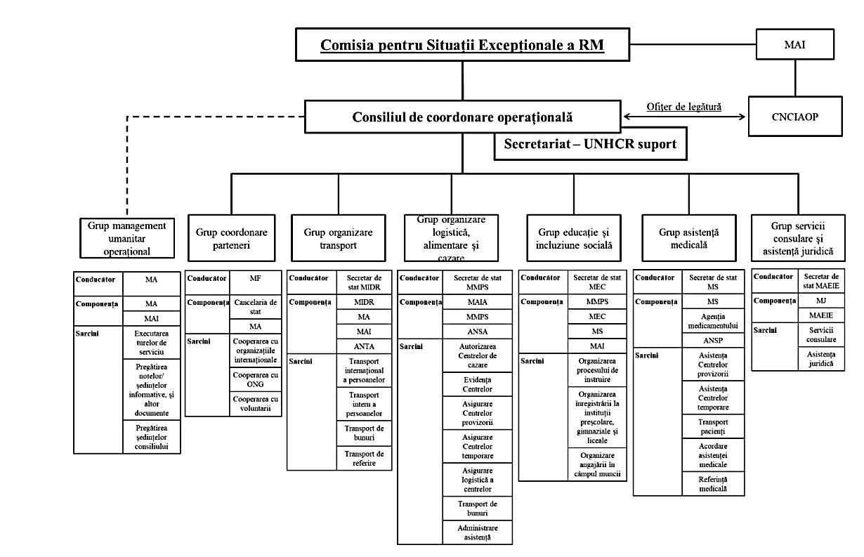
Figure 7. Structure of the Operational Coordination Council

- At the local level, the assistance activities are to be coordinated by the Commissions for Extraordinary Situations of Level 2 LPAs. These commissions are active for the entire duration of the state of emergency and will meet within 24 hours at most of each meeting of the Commission for Extraordinary Situations to adopt measures to ensure the implementation of the decisions. Also, the local Commissions were empowered to carry out the analysis of the spaces that can be used for the temporary placement of refugees and to inform the CSE about it.
- The National Agency for Social Assistance (ANAS) was empowered to supervise the RAC network. ANAS approved the setting up of temporary placement centres and the termination of their activity, based on the activity regulation approved by the MLSP. Territorial social assistance structures have designated community social assistants and social workers to serve the temporary placement centres. CSE allowed the placement of foreign refugees from Ukraine in the placement centres subordinated to the MLSP, based on the needs assessment carried out by social workers according to the standards developed by ANAS.
The Ministry of Finance has allocated to the Level 1 and Level 2 Local Public Authorities and the Ministry of Labour and Social Protection the necessary resources to adapt and operate the accommodation objectives in the temporary placement centres, based on the centralized requests presented by the Ministry of Labour and Social Protection.
- The Government established a salary increase for the employees of institutions involved in working with refugees, but in practice the staff working in the field are exhausted and are very little financially motivated. According to the CSE Decision 'During the state of emergency, the staff trained directly in the process of managing the migration flow and refugees and ensuring public order and security related to it, the staff transferred to a special activity regime within the Ministry of Internal Affairs, the Ministry of Defence, the Ministry of Labour and Social Protection and within the administrative authorities and institutions subordinate to them, as well as the staff within the territorial social assistance structures, social assistants and social workers trained in this process, benefit from the increased compensation for work performed in conditions of increased health risk, in accordance with Article 139¹ of the Labour Code'.
- Territorial social assistance structures will appoint community social assistance and social workers to provide humanitarian assistance services to refugees at the Provisional Centres for the Management of the Flow of Foreigners. Local public authorities, public institutions, state-owned companies and trade union organizations will make the subordinate accommodation objectives available to the territorial social assistance structures for the creation of Temporary Placement Centres for refugees.
- Personal support services for refugee children with disabilities. By the decision of the service provider, Ukrainian children with disabilities benefit from 'Personal Assistance' social service based on the disability certificate obtained in Ukraine, if they meet the eligibility conditions stipulated in point 2 of the Instruction on how to determine eligibility for the 'Personal Assistance' service, approved by Government Decision no. 314/2012. The expenses for the provision of the 'Personal Assistance' social service are covered from the financial means allocated within the Memorandum of Understanding signed between the Ministry of Labour and Social Protection and the United Nations Children's Fund. The service provider ensures the necessary support to parents/legal representatives of refugee children with disabilities in the preparation of the child's documents/file for determining the degree of disability and submission/registration to the territorial structure of the National Council for Determination of Disability and Work Capacity.
- Organizations providing support to Ukrainian refugees with disabilities can be divided into several categories.

- Assistance provided by international organizations does not effectively respond to the needs of refugees with disabilities. Expenses related to medications, medical products, seasonal clothing, sign language interpretation, support services (personal assistance, ASD child services), etc. are not sufficiently covered by assistance programs.
Assistance to refugees, including the monetary support provided, must take into account the needs to cover the costs related to the disability, which are additional to the current living costs.
- Refugees who turned to the CDPD requested the following types of assistance:
- medicines – 25% of cases;
- winter clothing/shoes – 15%;
- medical consultations (specialist doctors) – 12%;
- assistive and mobility devices – 12%;
- medical equipment – 6%;
- hygiene products – 6%;
- financial aid – 6%;
- food products – 5%;

- Many refugees with disabilities require disability-related assistive devices. There are few organizations that offer this type of support and the needs are not covered. 12% of the people who turned to the CDPD for support requested various assistive devices: wheelchairs, walking frames, canes, crutches, orthopaedic shoes, etc. 7.5% requested eye glasses and 7.5% requested hearing aids. Hearing aids are granted only to citizens of the Republic of Moldova, according to the waiting list (for children - 3 years, for adults - 7 years). The Government of the Republic of Moldova does not provide hearing aids for refugees. ASRM receives hearing aids from donations (in different states, they can also be worn and of different sizes), some of which can be offered to refugees, if the respective device fits the given beneficiary. People requested crutches, walking frames, as their health condition worsened. They requested seasonal orthopaedic footwear.
The RAC with which we discussed mentioned that they repeatedly sent the information to the MLSP about how many people need canes and eye glasses, but they did not receive anything.
- During the winter period, it was found that many people needed seasonal clothing and footwear. Many left home with minimal things and did not take warmer clothes with them. No effective refugee assistance mechanism has been identified that would be addressed to cover this need.
- Refugees with disabilities frequently requested transportation support. People with mobility disabilities, parents with children with disabilities needed specialized transport services to go to the doctor, the pharmacy, the embassy and for other personal needs, as intercity public transport in the Republic of Moldova is completely inaccessible.
Refugees requested that urban public transport be free for the persons with disabilities. 7% of CDPD calls refer to transport accessibility for refugees with disabilities.
- Parents of children with disabilities have reached out saying they need gluten-free food. RAC where they stay do not provide them with gluten-free food, so the parents have to cook for themselves. The products are more expensive and to comply with the diet, the dishes must be new, clean, untouched by products containing gluten. Individual tableware is required to prepare gluten-free food.
- Autistic children need to attend therapy sessions. These are very expensive for them, about 7000 lei per month. The costs are currently covered by private sponsorships, by NGOs, but it is not known for how long this will still be possible. Parents mentioned that in Moldova, children with autism spectrum disorders can benefit from high quality services, which they did not have in Ukraine.
- People with hearing disabilities rely heavily on sign language interpretation services, offered with the support of the Association of the Deaf of the Republic of Moldova (ASRM). Some were helped by the Association of the Deaf from Ukraine or other deaf people (including by phone) to reach Moldova. For the completion of documents, medical assistance, submission of documents for financial aid or other type of support, people with hearing disabilities need the support of a sign language interpreter. The costs for these services were covered only from ASRM resources.

SAFETY AND INTEGRATION
- Refugees with disabilities feel safe in the Republic of Moldova. Most of them, however, are willing to go back to Ukraine, especially the elderly people, as soon as the conditions in their country are favourable. Part of the people, especially from the first months of the war, fled because of the military operations, the bombings, for the safety of the family. It was difficult for them to go underground at night with children with disabilities or elderly people. The children were scared when they heard explosions. It was even more difficult for children with autism, for the elderly people.
Another group of people, who came in September-December 2022, left because they had no water, electricity, heating. These conditions made life very difficult for families with a person with a disability, child or elderly person.

Mr D. (Odessa): 'I stay in Moldova because I am closer to Ukraine. I want to go home faster. As soon as the war ends, I am leaving for Ukraine'.

- Refugees with disabilities believe that, in general, in Moldova is ok. Most do not want to leave to the EU. They are grateful for that fact that people are good, friendly, language is a big advantage, as most of them speak Russian. This is also confirmed by UNHCRdata: only 18% of refugees intend to go to another country in the near future, the rest want to stay in Moldova (53%), return to Ukraine (9%) or not yet decided (20%).
Mrs S. (Zaporozhe): 'It is ok in Moldova. We have no problems with the language and there is a cultural similarity. They feed us, we have a roof to shield our heads, it is warm, there is electricity'.
- Refugees with disabilities appraise the level of integration in the local community as acceptable. The main reported difficulties are related to the reduced physical accessibility of buildings, streets and transport.

Mr A. (Vinita): 'It is better in Europe, it is more inclusive. I would like to go to Germany, but I am waiting for a friend of mine.'

CONCLUSIONS AND RECOMMENDATIONS
- Implementing the principles of respecting the needs of persons with disabilities in humanitarian action, as defined by the UN Convention on the Rights of Persons with Disabilities and international standards (such as the IASC Guidelines on Inclusion of Persons with Disabilities in Humanitarian Action).
- Collecting and analysing systematic data on Ukrainian refugees with disabilities should be strengthened to inform humanitarian response, early intervention agenda, policy development and advocacy on sustainable solutions, taking into account refugee flow dynamics and changing regional context.
- The database to be established regarding the persons benefiting from temporary protection (in accordance with the Government Decision no. 21 of 18.01.2023) must contain data on refugees with disabilities.
ANAS/UNCHR statistical reports should include data on the number of persons with disabilities, disaggregated by sex, type of disability and region.
- Closely examining the practice of other UE states hosting refugees from Ukraine, in terms of interventions and policies for refugees with disabilities is necessary, in order to apply good practices in the context of the Republic of Moldova.
- Cash assistance should be increased for the elderly persons and the persons with disabilities. Monetary support is the main form of support and the main source of income for most refugees with disabilities in Moldova. This should be extended and supported. Greater support should also be given to elderly refugees and those with disabilities, those who have serious health problems and other frequent disability-related expenses.
- Improving the system of access to specialized healthcare and free/compensated medicines for people with disabilities and elderly refugees is needed.
- Taking over/implementing by NGOs of the refugee feeding program, monetary support program, payment of communal services for RAC, etc. proved to be a positive experience. Likewise, other programs could be taken over by NGOs, such as: provision of medicines, assistive and mobility devices for people with disabilities, etc.
- Improving the accessibility of the network of refugee placement centres. Identifying those locations in the existing centres network where one could invest or create other new centres, which would have accessible buildings, accommodation conditions, and would be located in areas with access to infrastructure, medical services, work.
- Organizing trainings for employees of central and local authorities involved in the activity with Ukrainian refugees with disabilities.
- Strengthening the capacities of authorities in charge of coordinating and providing assistance to refugees from Ukraine (ANAS, territorial social assistance structures) by hiring additional staff and ensuring an appropriate salary level for work with refugees.
- Expanding the housing rental cost compensation program for vulnerable people, within the limits of the costs of maintaining a person in the RAC (130 lei per day per person/200 USD per month).
- Expanding the feeding program to provide the possibility to also benefit people living in families, not only those placed in RAC.
- Providing refugees in vulnerable families with subscriptions or the right to travel free of charge in municipal public transport.
- In order to integrate them into work, refugees with disabilities need employment support services: assisted employment to identify the job that meets their skills, intermediation with the employer.
- Developing a strategy to cover the costs related to the purchase of seasonal clothing/shoes. An urgent need for refugees with disabilities this fall was the provision of winter clothing. The monetary aid offered only covers current expenses and it is possible that this type of requests will be repeated in the spring. One of the possible solutions would be to grant a single bonus to the material aid, for example, 1500 lei per person in March 2023.

References

- UN Convention on the Rights of Persons with Disabilities (2006), at: https://bit.ly/1PxgebQ.
- IASC Guidelines, Inclusion of Persons with Disabilities in Humanitarian Action, 2019
https://interagencystandingcommittee.org/system/files/2020-11/IASC%20Guidelines%20on%20the%20Inclusion%20of%20Persons%20with%20Disabilities%20in%20Humanitarian%20Action%2C%202019_0.pdf.
- Humanitarian inclusion standards for older people and people with disabilities, CBM, HelpAge, HI, 2018 https://reliefweb.int/report/world/humanitarian-inclusion-standards-older-people-and-people-disabilities.
- The Sphere Handbook, Edition 2018 https://spherestandards.org/wp-content/uploads/Sphere-Handbook-2018-EN.pdf.
- Including Children with Disabilities in Humanitarian Action: Child Protection. UNICEF, 2021 https://www.corecommitments.unicef.org/kp/including-children-with-disabilities-in-humanitarian-action.
- Need to Know Guidance: Working with Persons with Disabilities in Forced Displacement. UNHCR, 2019 https://www.unhcr.org/4ec3c81c9.pdf.
- Moldova Needs Assessment of Older Refugees, HelpAge Moldova, September 2022 https://reliefweb.int/report/moldova/moldova-needs-assessment-older-ukrainian-refugees-14-september-2022.
- Activity report of the Single Crisis Management Centre (February 24 - August 24, 2022) https://gov.md/sites/default/files/raport_de_activitate_cugc_15.09.2022.pdf.
- Annexes of COMBINED SECOND AND THIRD REPORTS OF UKRAINE ON THE IMPLEMENTATION OF THE CONVENTION ON THE RIGHTS OF PERSONS WITH DISABILITIES (2020).
https://tbinternet.ohchr.org/_layouts/15/treatybodyexternal/Download.aspx?symbolno=INT%2FCRPD%2FADR%2FUKR%2F43434&Lang=en.

Cover image by https://www.freepik.com/free-photo/colorful-abstract-wall-background_15073916.htm.

https://data.unhcr.org/en/country/mda.
CSE Decision no 49 of 30.11.2022, Consolidated Report on the need to extend the state of emergency.
https://www.anas.md/wp-content/uploads/2023/01/REACH_MDA_Factsheet_RAC-Weekly-Needs-Monitoring_2022-12-27_RO-1.pdf.
Republic of Moldova: Protection Monitoring and Profiling: Profiles, Needs & Intentions of Refugees from Ukraine (4552 interviews were conducted between May and August 2022). https://data.unhcr.org/en/dataviz/250?sv=0&geo=680.
https://www.who.int/news-room/fact-sheets/detail/disability-and-health.
UN Convention on the Rights of Persons with Disabilities (2006). https://bit.ly/1PxgebQ.
https://www.washingtongroup-disability.com/question-sets/wg-short-set-on-functioning-wg-ss/.
National Bureau of Statistics, Persons with disabilities in the Republic of Moldova in 2021. https://statistica.gov.md/ro/persoonele-cu-dizabilitati-in-republica-moldova-in-anul-2021-9460_60129.html.
COMBINED SECOND AND THIRD REPORTS OF UKRAINE ON THE IMPLEMENTATION OF THE CONVENTION ON THE RIGHTS OF PERSONS WITH DISABILITIES (2020). Annexes. https://tbinternet.ohchr.org/_layouts/15/treatybodyexternal/Download.aspx?symbolno=INT%2FCRPD%2FADR%2FUKR%2F43434&Lang=en.
https://tbinternet.ohchr.org/_layouts/15/treatybodyexternal/Download.aspx?symbolno=INT%2FCRPD%2FSTA%2FUKR%2F9545&Lang=en.
Point 2, CSE Decision no 1 of 24.02.2022, as amended by subsequent provisions.
Government Decision no 21 of 18.01.2023, published in the Official Gazette no. 21-22 of 26.01.2023.
https://data.unhcr.org/en/dataviz/250?sv=0&geo=680.
https://reliefweb.int/report/moldova/moldova-refugee-accommodation-centre-rac-weekly-needs-monitoring-update-27122022-enro.
https://gov.md/sites/default/files/raport_de_activitate_cugc_15.09.2022.pdf.
Information note to the draft Government Decision: https://cancelaria.gov.md/sites/default/files/document/attachments/771.pdf.
CSE Decision no 27 of 21.06.2022. The report on the need to extend the state of emergency.
https://www.anas.md/wp-content/uploads/2022/03/Ordin26022022.pdf.
https://reliefweb.int/attachments/e6a11ee4-2e5e-4495-9f35-4958a2dfeb25/REACH_MDA_Factsheet_RAC-Weekly-Needs-Monitoring_2022-12-27_EN.pdf
https://www.anas.md/wp-content/uploads/2023/01/REACH_MDA_Factsheet_RAC-Weekly-Needs-Monitoring_2022-12-27_RO-1.pdf
https://reliefweb.int/report/moldova/moldova-needs-assessment-older-ukrainian-refugees-14-september-2022.
Moldova Needs Assessment of Older Refugees, 14 September 2022, Help Age https://reliefweb.int/attachments/46ef0a9b-062c-4de4-b993-03c09ba17d95/Moldova%20-%20Needs%20Assessment%20of%20Older%20Refugees%20-%2014%20September%202022.pdf.
Moldova Needs Assessment of Older Refugees, 14 September 2022, Help Age. https://reliefweb.int/attachments/46ef0a9b-062c-4de4-b993-03c09ba17d95/Moldova%20-%20Needs%20Assessment%20of%20Older%20Refugees%20-%2014%20September%202022.pdf.
CSE Decision no. 53/05.12.2022, amended by Decision no 55 of December 22, 2022. https://gov.md/sites/default/files/document/attachments/modificat_dispozitia_cse_nr._53_d_55.pdf..
Point 3, CSE Decision no. 3 of 27.02.2022.
Point 8, CSE Decision no. 18 of 28.04.2022.
CSE Decision no. 12 of 25.03.2022.
CSE Decision no. 55 of 22.12.2022.
https://www.anas.md/wp-content/uploads/2022/10/Round-01.-REACH_MDA_Factsheet_RAC-Weekly-Needs-Monitoring_2022-03-14_RO.pdf.
https://www.anas.md/wp-content/uploads/2022/10/Round-17.-REACH_MDA_Factsheet_RAC-Weekly-Needs-Monitoring_2022-07-11_RO.pdf.
https://reliefweb.int/report/moldova/moldova-refugee-accommodation-centre-rac-weekly-needs-monitoring-update-27122022-enro.
UN CRPD Committee 27th Session Report. https://www.ohchr.org/sites/default/files/documents/hrbodies/crpd/statements/2022-09-09/Situation-of-persons-with-disabilitie-in-Ukraine-in-CRPD-27th-session-Report.docx.
Profiles, Needs & Intentions of Refugees from Ukraine (Mai-August 2022). https://data.unhcr.org/en/dataviz/250?sv=0&geo=680.
Point 7, CSE Decision no 4 of 01.03.2022.
https://www.anofm.md/index.php/ro/node/20103.
https://reliefweb.int/attachments/945f074b-a955-4cbc-9bb3-aec92b3e821b/UNHCR_%20CWG%20meeting_Cash%20Programme%20for%20refugees.pdf.
https://cnas.gov.md/doc.php?l=ro&idc=244&id=6122&t=/Statistica/INFORMATIE-privind-beneficiarii-de-pensii-alocatii-sociale-de-stat-si-indemnizatii-adresate-familiilor-cu-copii-aflati-la-evidenta-Casei-Nationale-de-Asigurari-Sociale-la-situatia-de-01012023.
Point 20, CSE Decision no. 2 of 25.02.2022.
CSE Decision no. 14 of 14.04.2022.
CSE Decision no. 23 of 30.05.2022.
Point 2, CSE Decision no. 32 of 08.08.2022.
Consolidated report on the need to extend the state of emergency on the territory of the Republic of Moldova, CSE Decision no 27 of 21.06.2022.
Moldova Needs Assessment of Older Refugees, 14 September 2022, Help Age. https://reliefweb.int/attachments/46ef0a9b-062c-4de4-b993-03c09ba17d95/Moldova%20-%20Needs%20Assessment%20of%20Older%20Refugees%20-%2014%20September%202022.pdf.
Point 12, CSE Decision no 10 of 15.03.2022.
Consolidated report on the need to extend the state of emergency on the territory of the Republic of Moldova, CSE Decision no 27 of 21.06.2022.
CSE Decision no. 3 of 27.02.2022.
The standard operating procedures of the Single Crisis Management Center, Annex no. 3 to CSE Decision no. 13 of 31.03.2022.
CSE Decision no. 5 of 02.03.2022.
Point 6, CSE Decision no 1 of 24.02.2022, as amended by subsequent provisions.
Point 8, CSE Decision no. 54 of 16.12.2022.
https://data.unhcr.org/en/dataviz/250?sv=0&geo=680.

